It was amazing to have had the opportunity this week to inspect quite a few yachts with our stellar Croatia DMC client, Via Tours. Not only do they custom craft exceptional land based journeys throughout the soul of Croatia and its diverse regions but they also are the leader in handling private yacht charter requests. Their access to gorgeous vessels is as impressive as their local connections. You’ll be thrilled and so will your clients and we’d love to connect you with them!

Right now you may be thinking 1 or all of 3 things:

-I’m intrigued but not sure how to approach a private yacht charter for my clients

-It’s too expensive

-I have no idea how this process works.

Relax.

Very few planners think all of these before they go forward for the first time! We are here to help make it easier and I’ll be sharing below the details on what I was able to personally inspect as well as general info that you need to know up front.

The first thing is the price: this is for the yacht rental itself. Charters generally run on a 7 night basis so you must take it for that entire time. On top of that price, you have to figure in something called an APA. This is an Advance Provisions Allowance and basically applies to all of the items that the charter will need to run its course. This includes estimations on fuel, food + beverage and any other costs related to the journey. A rule of thumb is about 30% of the boat charter price. This is due up front, in advance so that the captain and crew can accurately plan for your journey. The APA is an estimation and there is always a chance clients will either exceed it or not utilize all of it. Should they exceed it whilst on board, the balance will be due at the end of the charter and should it not be utilized, it can either be given back or left on the account as a means of gratuity (which is customary). Clients are provided an itemized breakdown of all costs and expenditures.

The clients are given an intensive questionnaire ahead of time as well prior to the journey down to the last detail- journey preferences, do they wish for the crew to be present and interactive or discreet, what kinds of F&B they want on board, when they like to eat, dietary restrictions/preferences, and a whole other litany of queries to help the crew really get a sense of who they are and what they like.

The yacht crews feature a capatain, a host/hostess, a chef preparing meals on demand, and additional stewards depending on the size of the boat.

And now, welcome on board to a lovely collection to consider.

AGAPE ROSE

Cabins- 12 for max occupancy of 24

Size- 158 m

Crew- 10

The Agape Rose is a GEM, simply put. This is perfect for larger groups, incentives, destination weddings, families, you name it for so many reasons. It is a mini cruiser that delivers a luxe experience that is entirely bespoke- the captain is also in fact the owner so he is quite passionate about each journey and personally invested in each group with a stellar team. Each cabin is decorated in light-shaded wood and feature top amenities, ample storage space and en-suite spacious bathrooms. I was most impressed by the total gym with multiple pieces of equipment and apparatus, a massage room, a sauna and even a media room with smart TV set up for gaming as well. The social spaces leave plenty of room to be together or to be on one’s own, with a large indoor salon with TV and full bar with multiple tables to multiple decks with tables for al fresco dining, plenty of sun lounges and jacuzzi. They have great knowledge of hidden bays and coves to discover and experience without other groups and yachts sailing up to your “private” swim area and for water toys, guests are spoiled for choice- 2 tenders, 2 jet-skis, flit board, 4 stand up paddle boards, a kayak, water skis, Ringo, and more. Absolutely one to watch for groups at an amazing value as well.

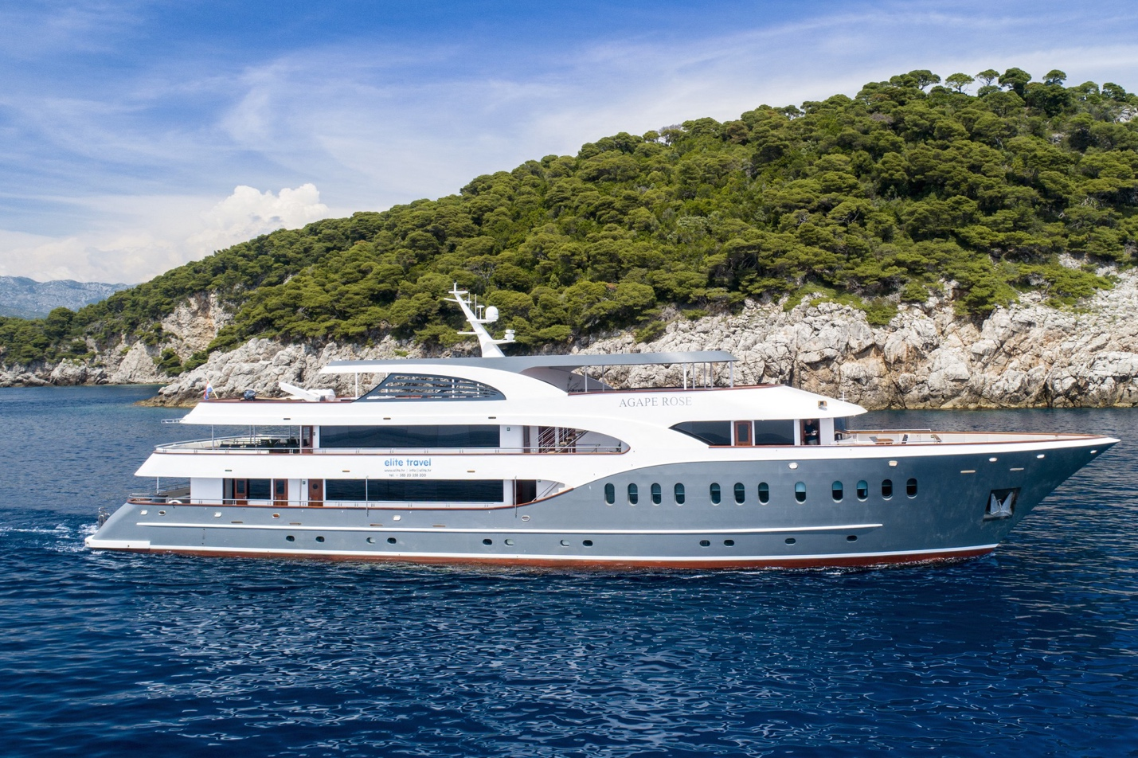

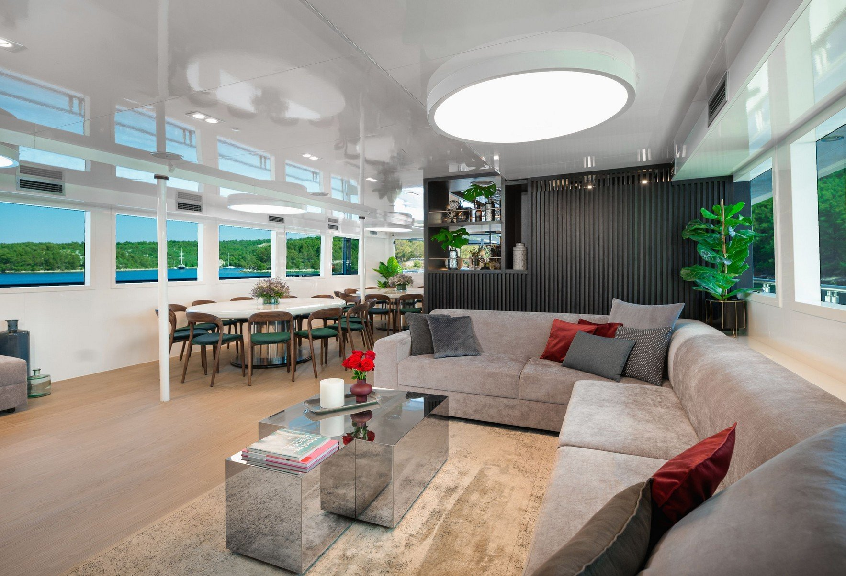

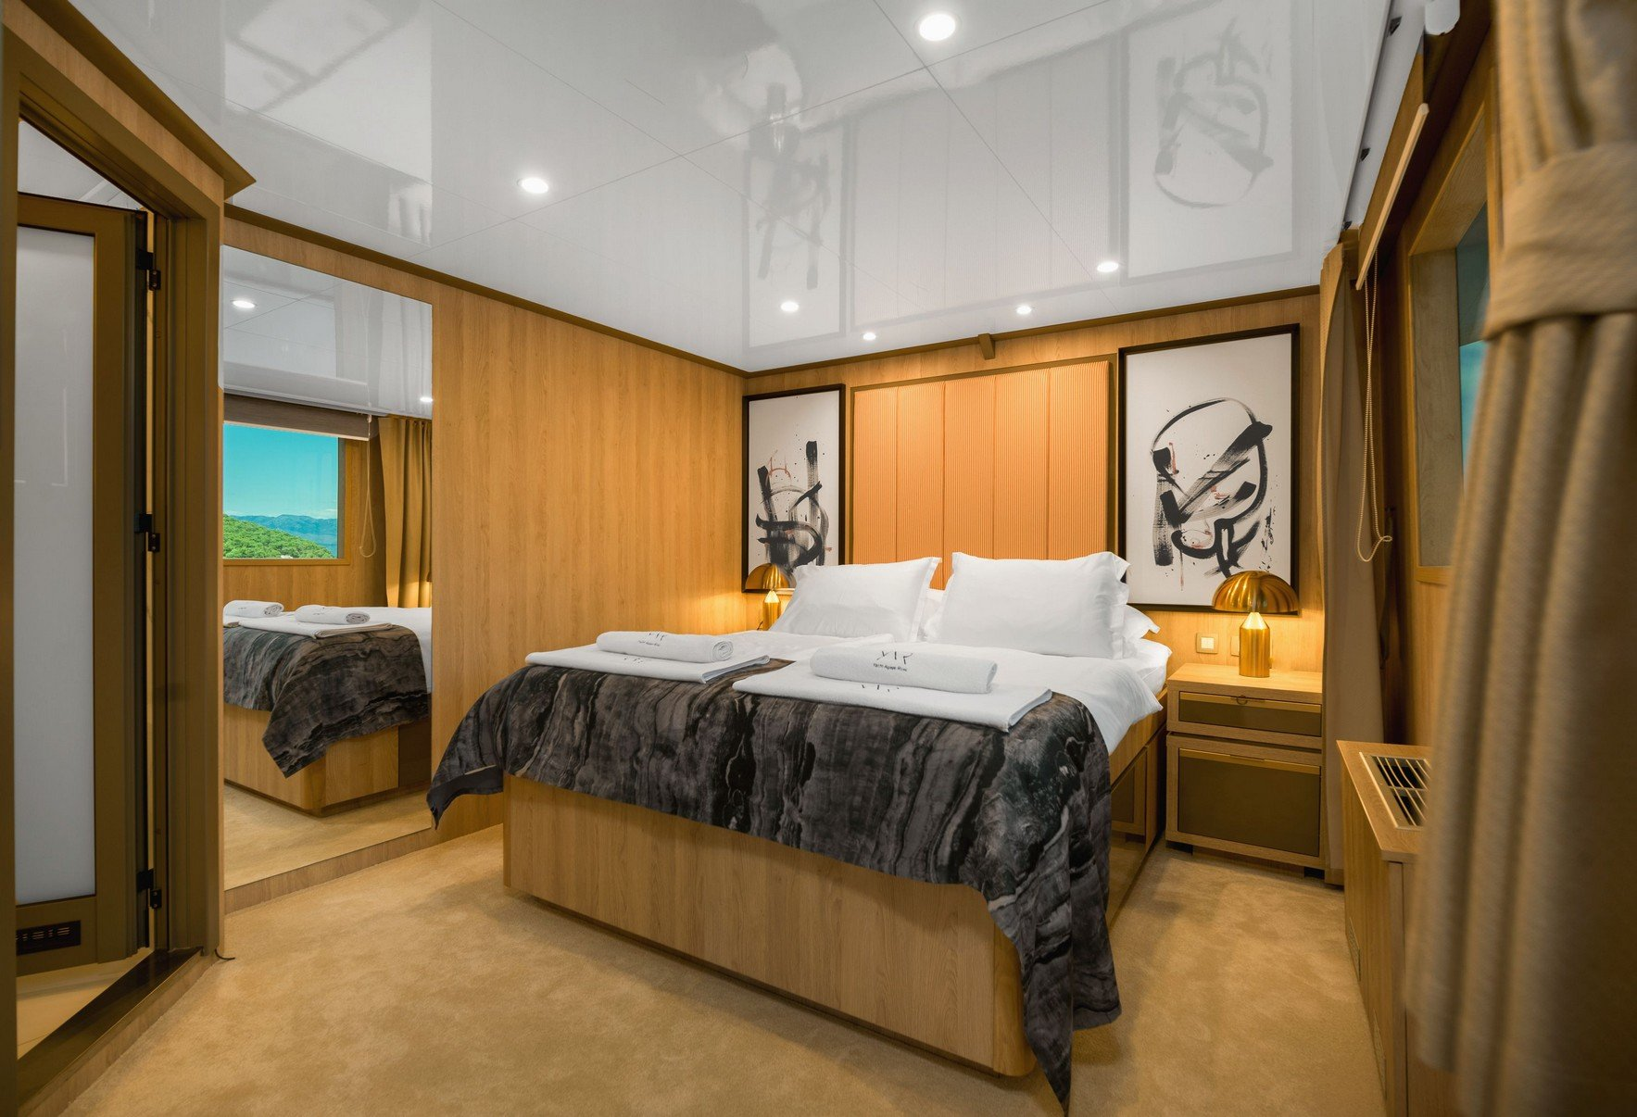

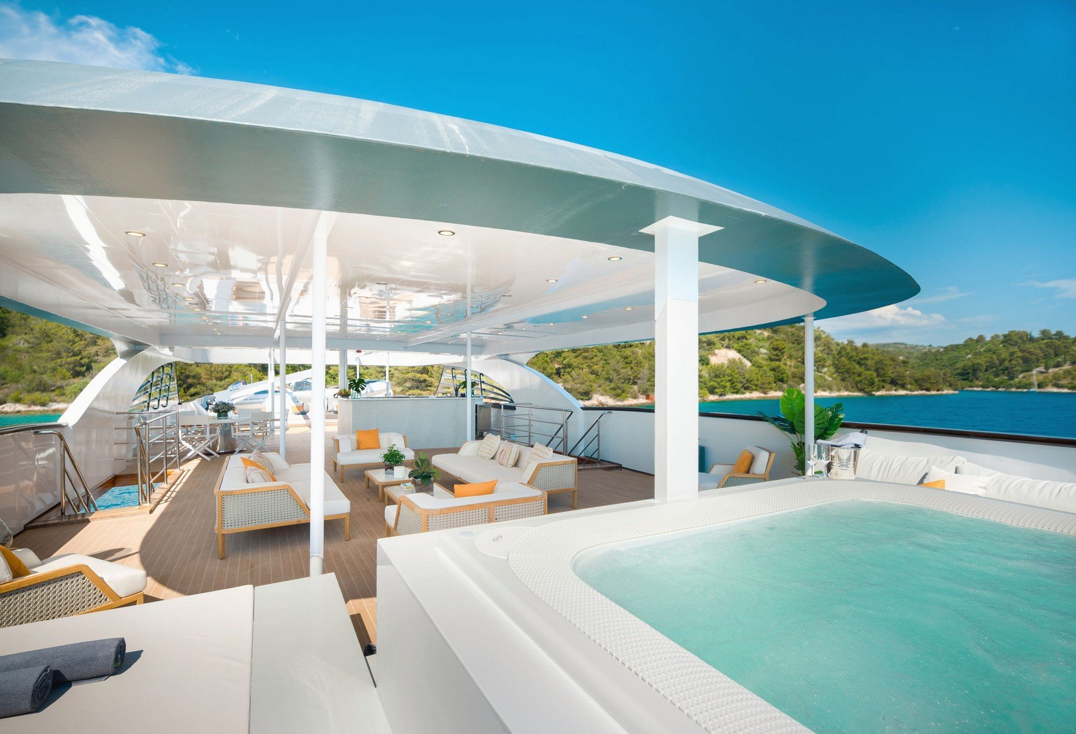

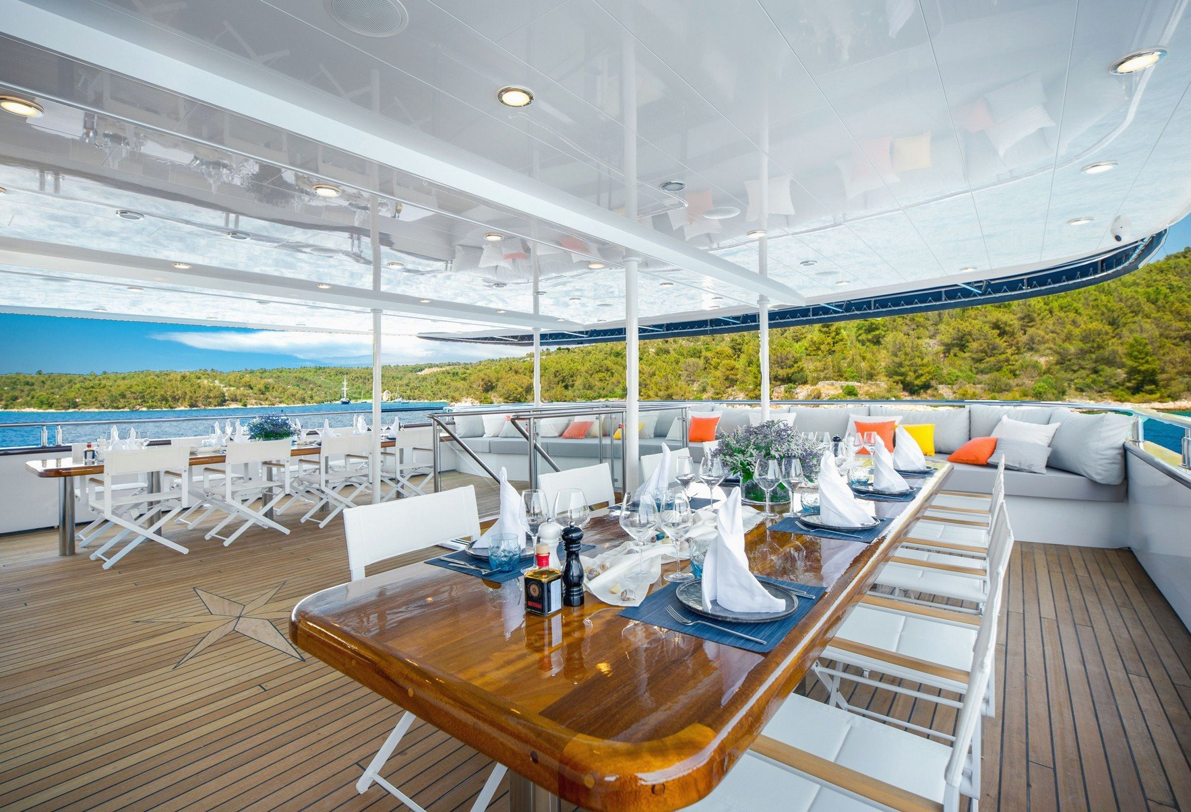

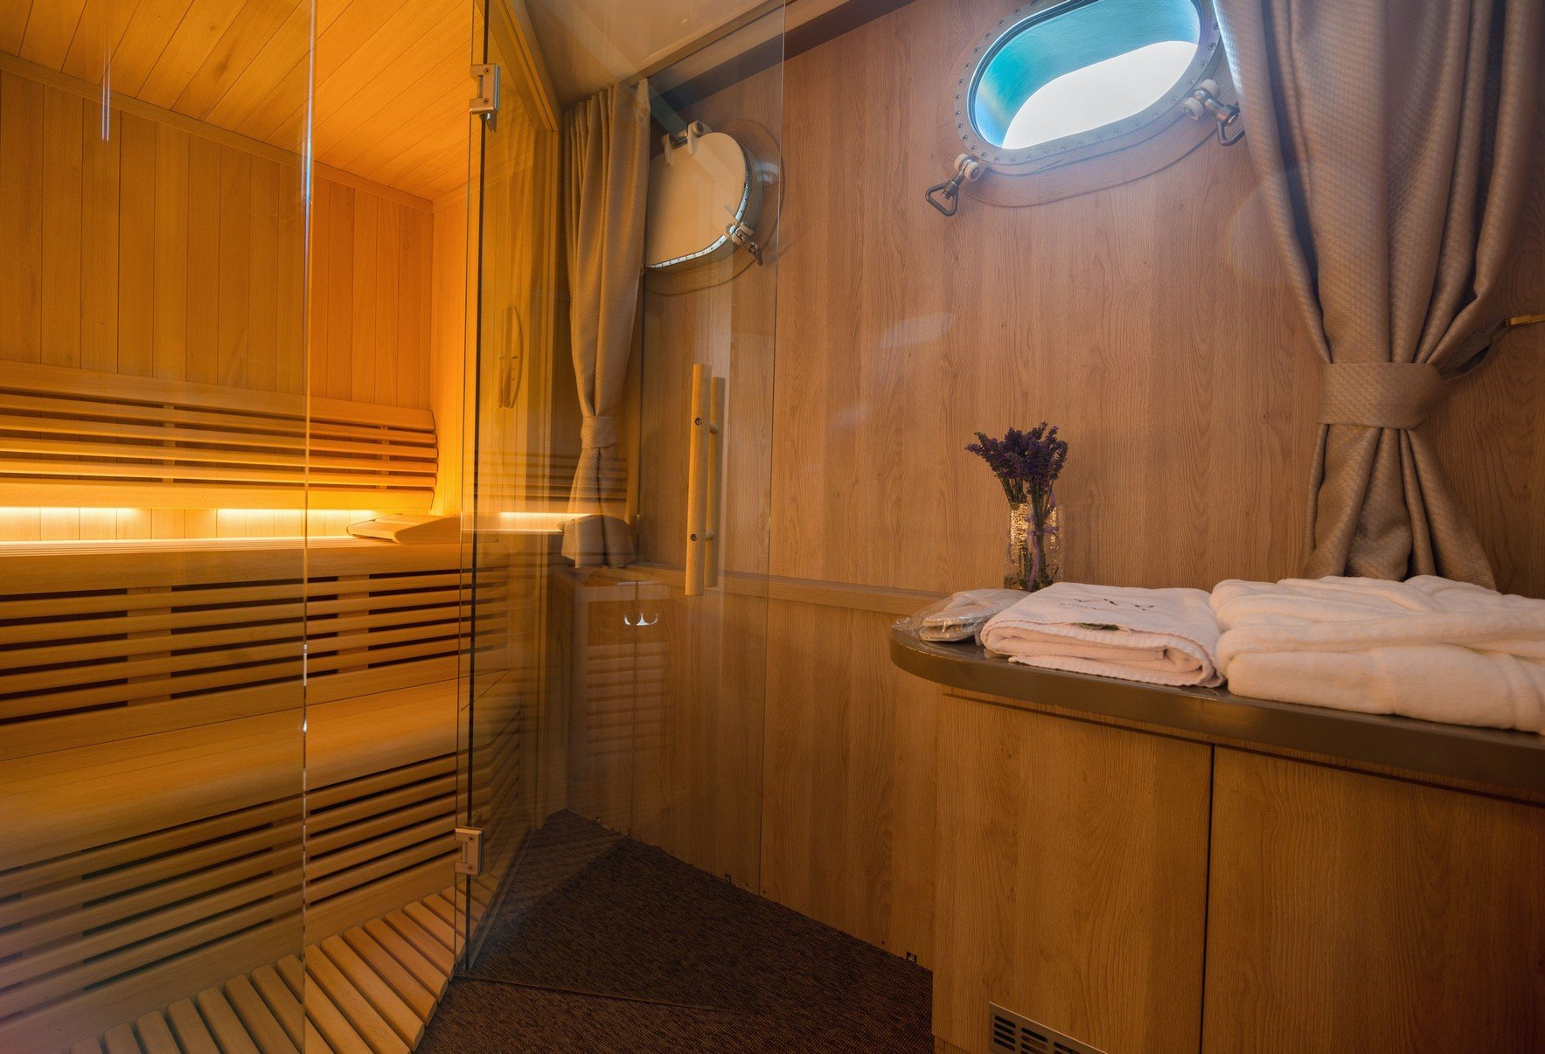

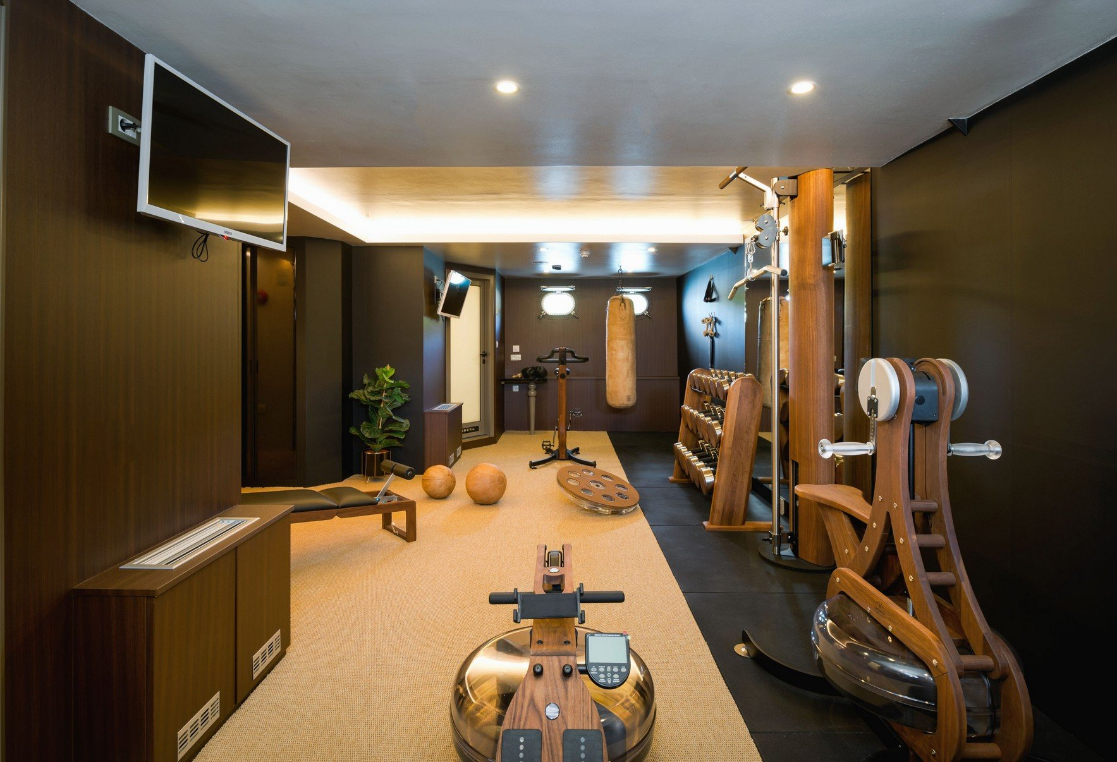

GRACE

Cabins- 5 for max occupancy of 10

Size- 28 m

Crew- 5

The Grace is elegant and feels much larger than it actually is which was the first impressive feeling, second is the bright naturally-lit salon (almost Scandinavian looking with color and furnishings style) with plenty of windows to let the sun shine in which really even opens up the space further. The salon is intimate yet with enough room for everyone to be comfortable when all together and is an ideal social space along with large TV and a formal dining table. Due to the windows, you have a great view eating in here as well as in the beautiful al fresco dining area up above on the deck where you can gaze at the ever changing scenery all around you. Cabins all feature en suite baths, contemporary design and are bright even below deck. There is a media room on board as well, a large low lying swimming platform for when you want to take a dip and a wide array of water toys including a tender, Jet Skiis, sea bob, Water skis kayak, donut, banana boat, paddle boards, fishing equipment and snorkeling gear. The works and it is a stunner for families and adults that want to feel like kids!

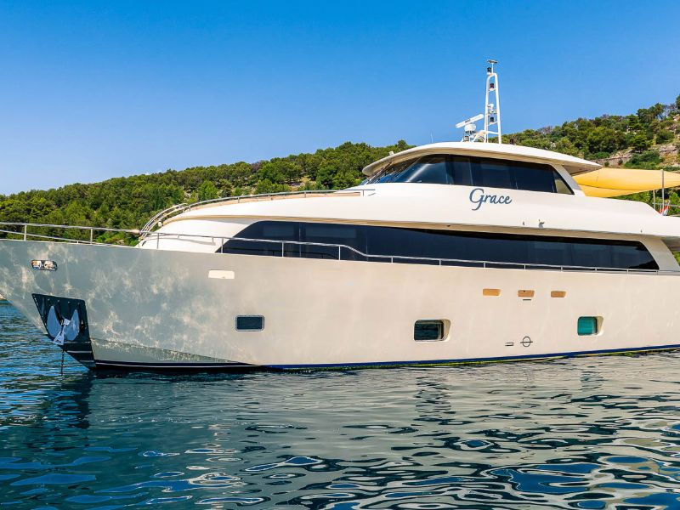

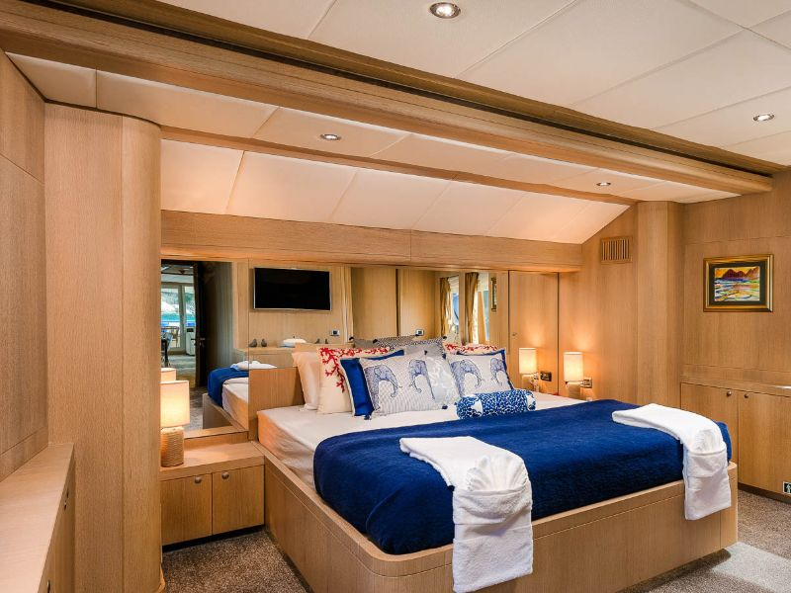

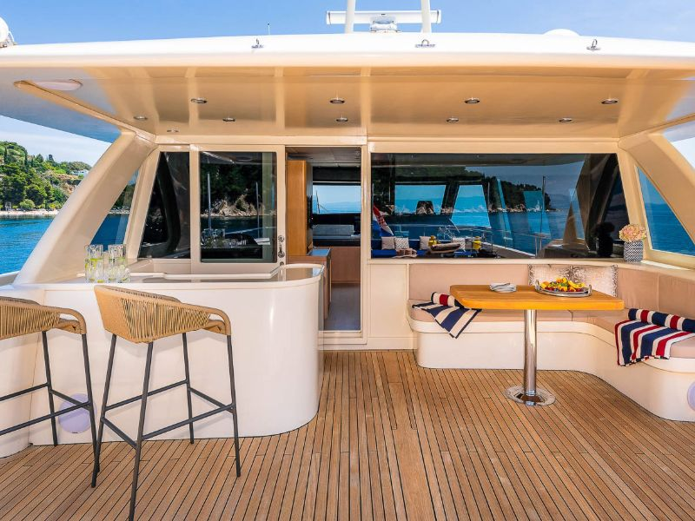

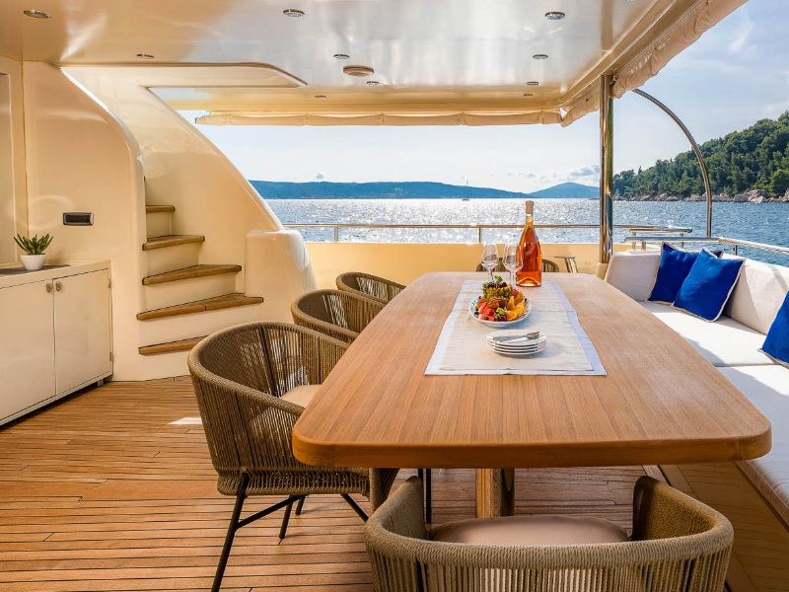

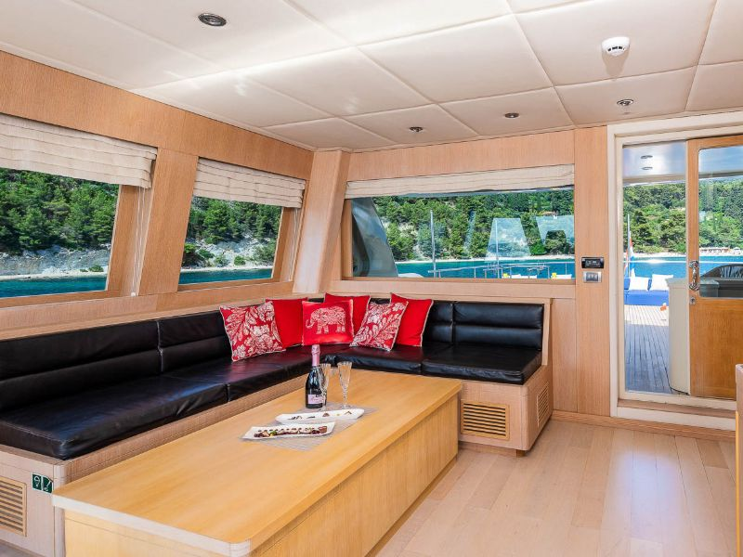

BABY 1

Cabins- 4 for max occupancy of 8

Size- 31 m

Crew- 5

This was a lovely stunner and feels much larger than its actual dimensions somehow, much like the Grace. Perhaps it’s the design which is bright, modern and quite sleek with white leather furniture accented by rich wood and more of an open plan feeling than others. The salon is laid out well for individual comfort and communal gathering with a nice sized LCD Tv and surround sound, plus a lovely dining area, there’s also a table on the deck for al fresco dining along with plenty of sunbeds, sofa space and a jacuzzi- all great places to spend the day soaking in the views. Accommodations are well equipped and larger than expected, with en suite bathrooms, modern amenities, entertainment systems and water toys include Jet Skis, inflatable SUPs, donuts, water ski, Sea Doo and wakeboard.. It definitely packs a huge amount of value in!

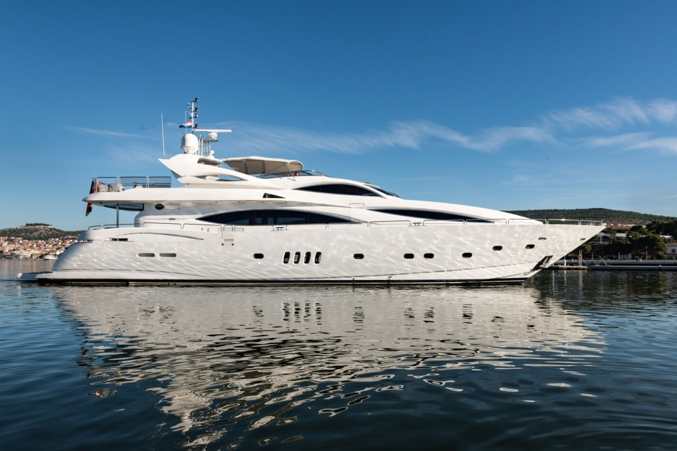

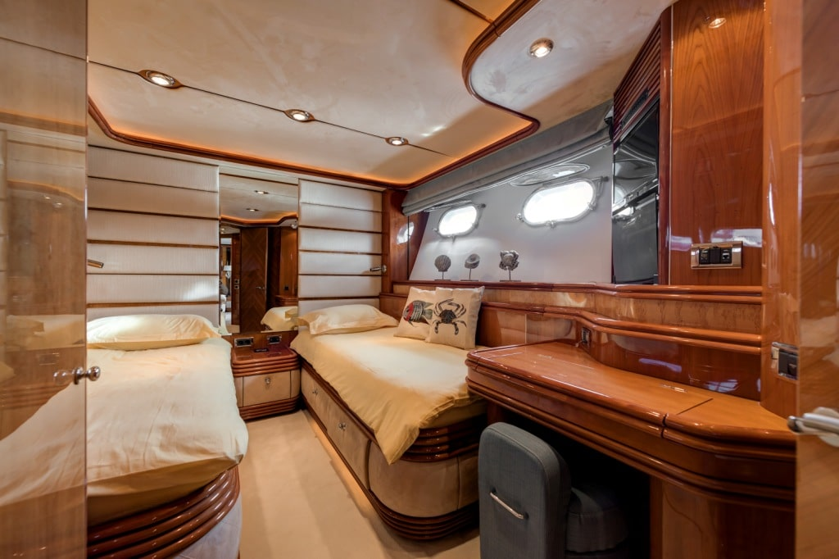

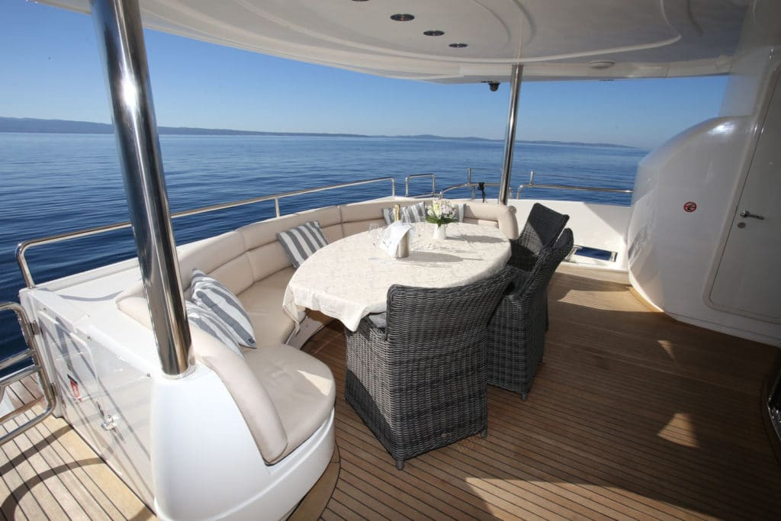

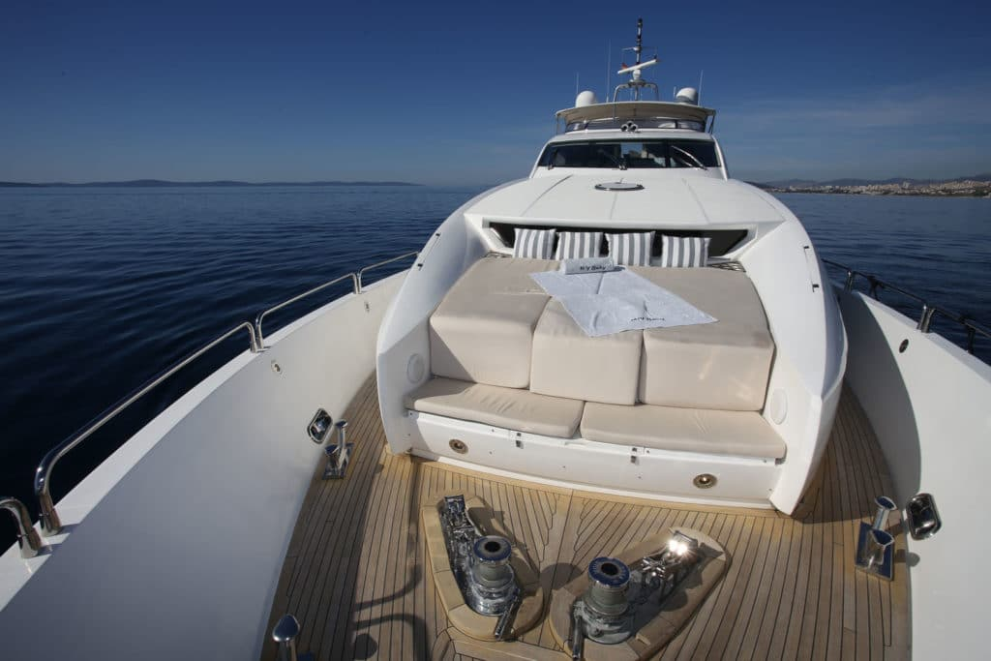

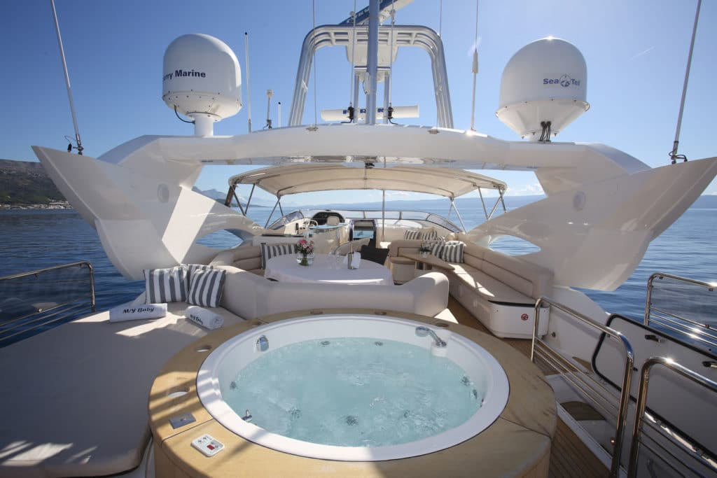

HEED

Cabins- 5 for max occupancy of 11

Size- 35 m

Crew- 6

This was an impressive vessel from the outside inward, it’s uniquely designed with a very extensive deck that features plenty of al fresco dining space, sun pads, jacuzzi and retractable awning for shade. That surprised me the most, as you really can envision a family or group really relaxing and spending time outdoors in the fresh air with plenty of space. I found the rooms to be exceptionally bright with an airy feel and unique design, ample closet space, curved furniture which make the rooms look bigger, plenty of natural light and large en-suite bathrooms. The salon is airy with indoor tables and elegant furnishings, separate dining area, large TV screen complete with smart features, enhanced sound system which is great as they also have karaoke, and water features include a powerful tender, Jet Skiis, go-cycle, e-surfboard, water skiis, inflatable sailboat and donut.

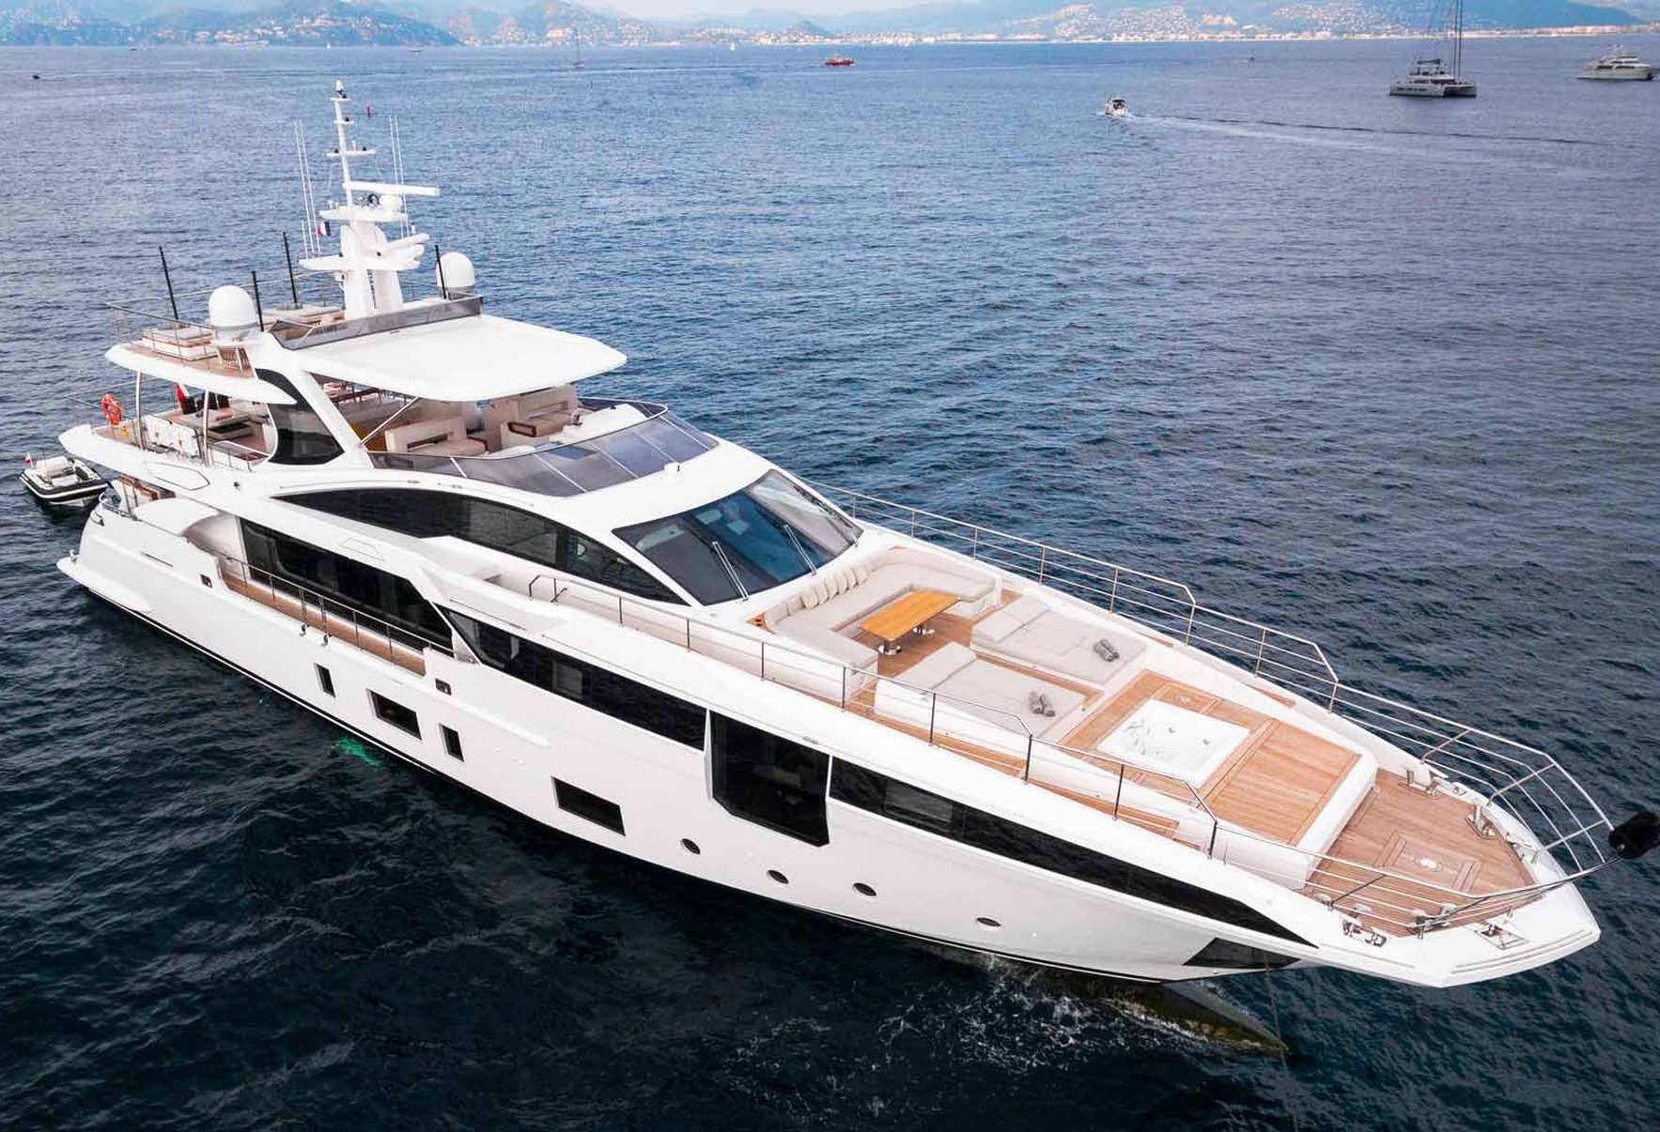

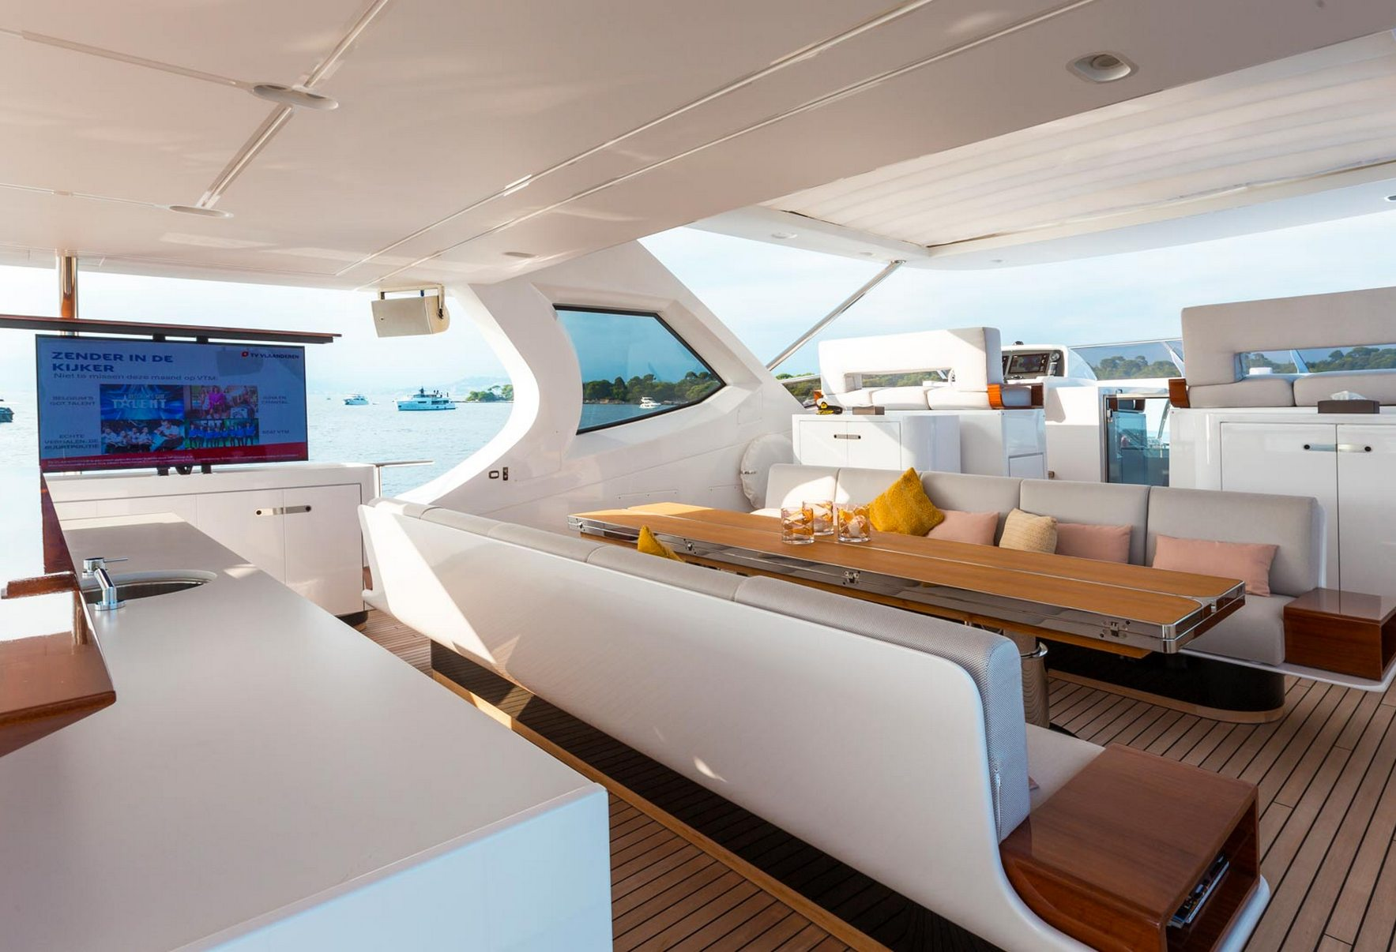

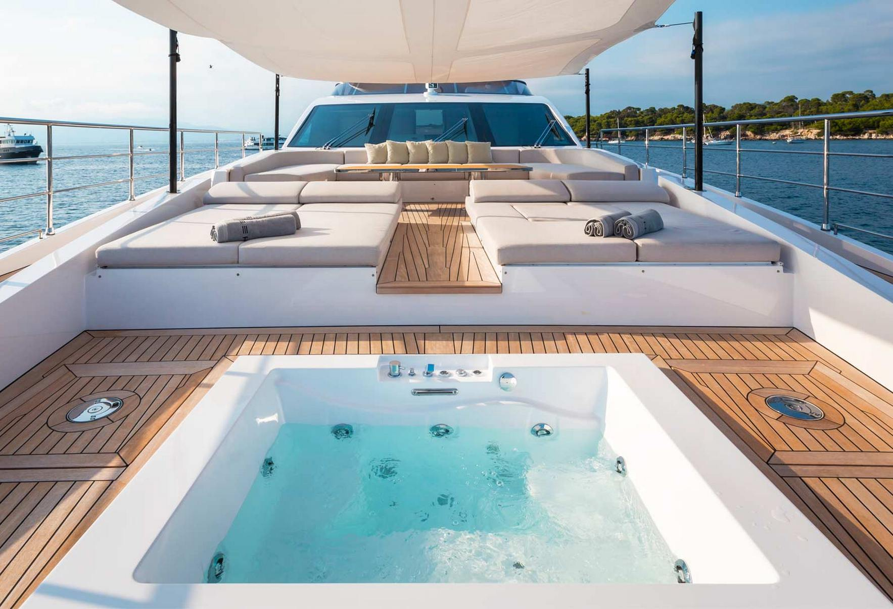

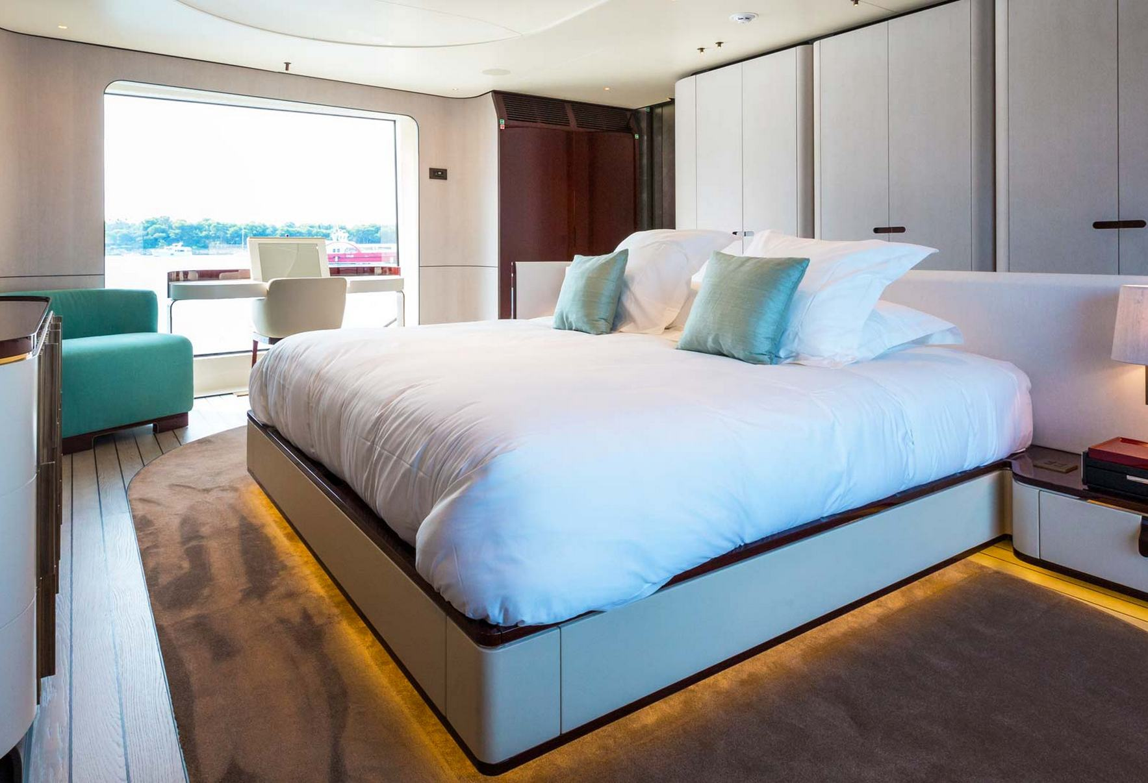

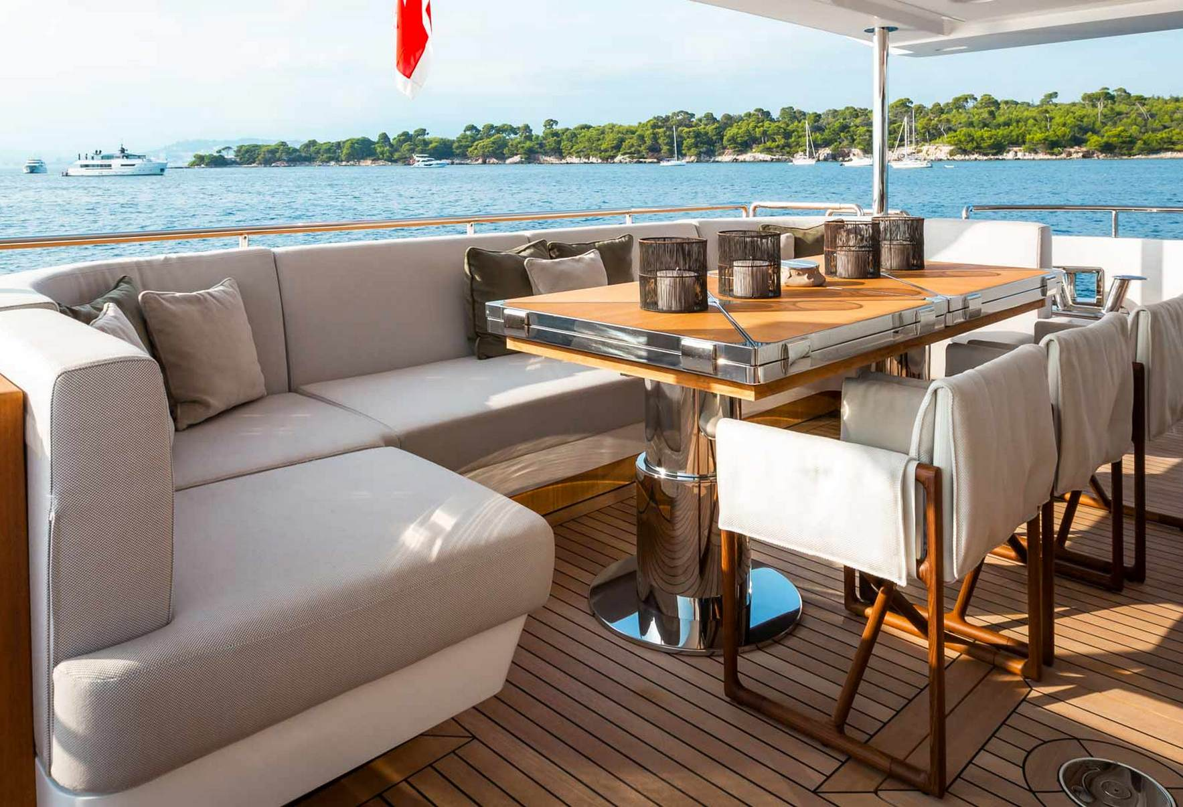

ANAVI

Cabins- 4 for max occupancy of 8

Size- 36.1 m

Crew- 6

This boat stands out right from its silvery aluminum exterior and can reach a speed of up to 30 knots., and the captain was engaging and welcoming. What also stands out is the interior of the salon when you first board, it’s done up in a Hamptons beach-chic style that is comfortable yet elegant and carries throughout with soft shades of whites and grays. There is a dining salon indoor and a lovely outdoor space with some workout equipment and a lovely bar/dining area as well with plenty of area to relax and sunbathe. Water toys include SUP, Jet Ski, Water Slide, Sea Bob, Donuts, Tender. It is a great it for families with kids or groups of friends.

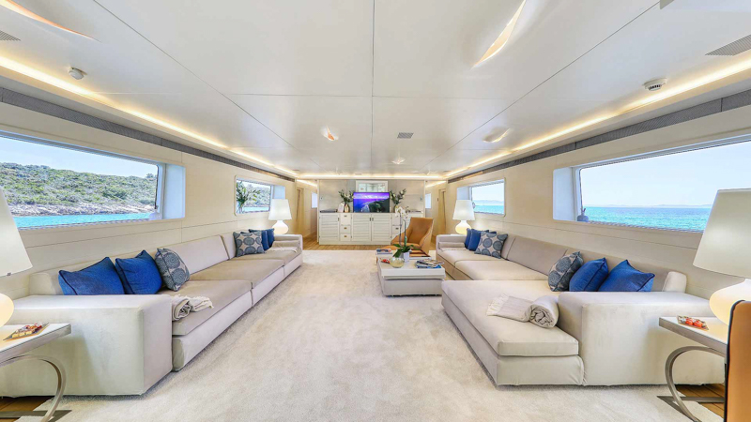

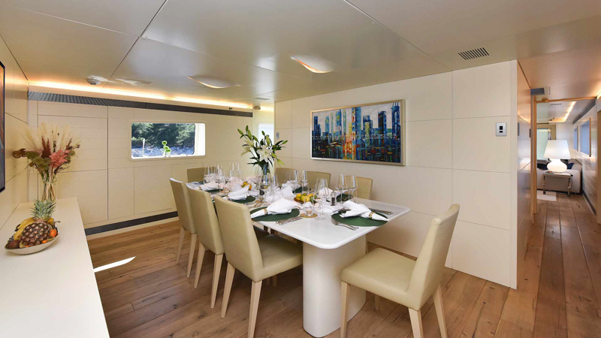

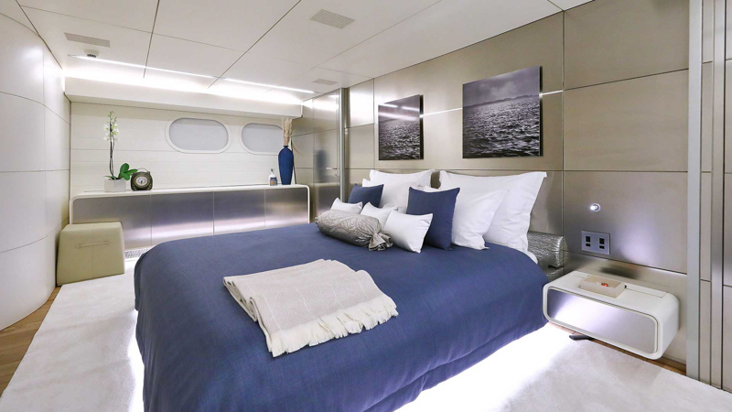

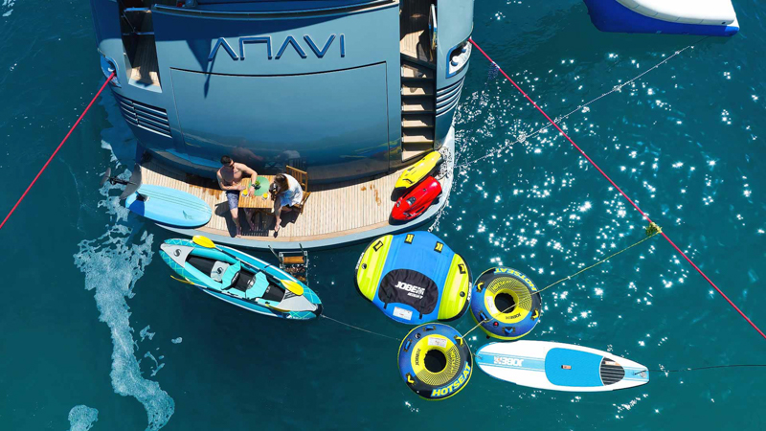

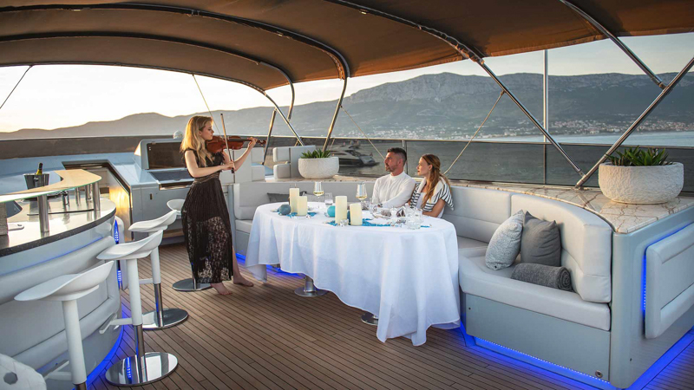

https://via-croatia.com/charter/anavi-motor-yacht/

AGAVE

Cabins- 4 for max occupancy of 8

Size- 26 m

Crew- 4

A more intimate experience with a stable smooth ride and truly a bright and airy feel due to the stylish design. The cabins are well appointed, again with impressive amenities and ultra spacious bathrooms with beautifully tiled mosaic style showers. The indoor dining area is bright and spacious, well positioned for natural light and there is an al fresco dining option as well as plenty of sunbathing spaces on the flybridge and the bow. Water toys include a tender plus powerful Jetskis, SUPs, E-foio and water skis plus inflatable toys to keep kids and adults engaged for hours!

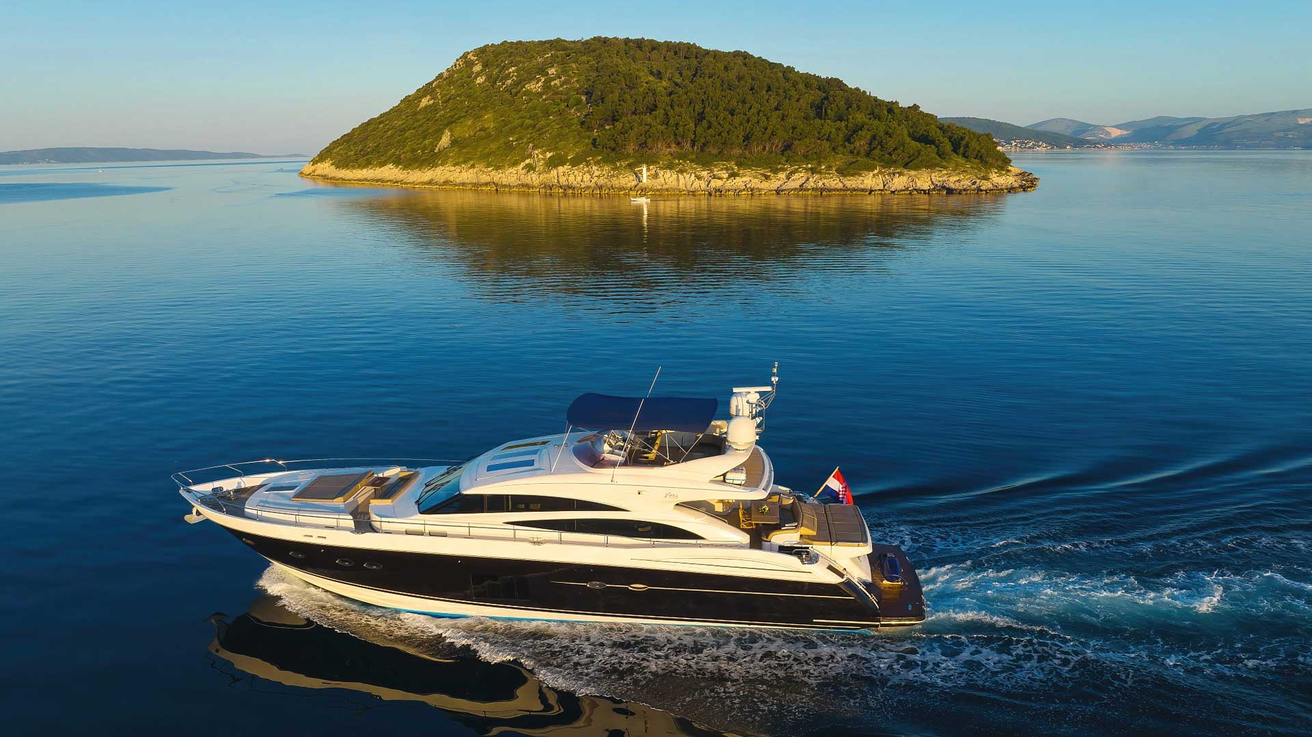

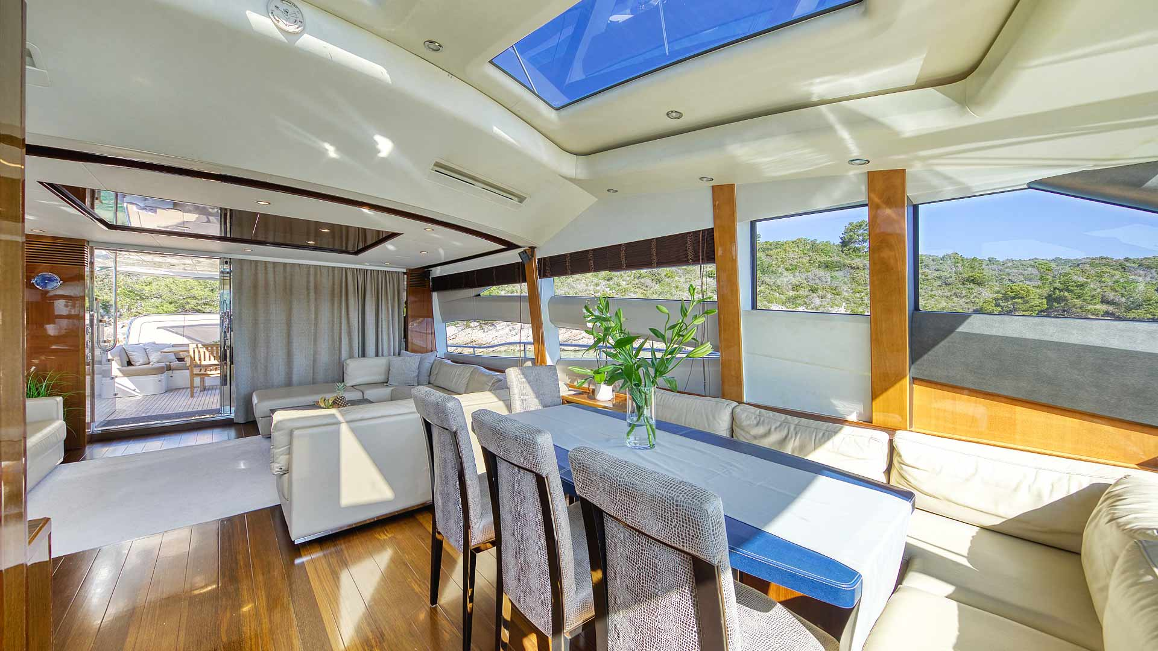

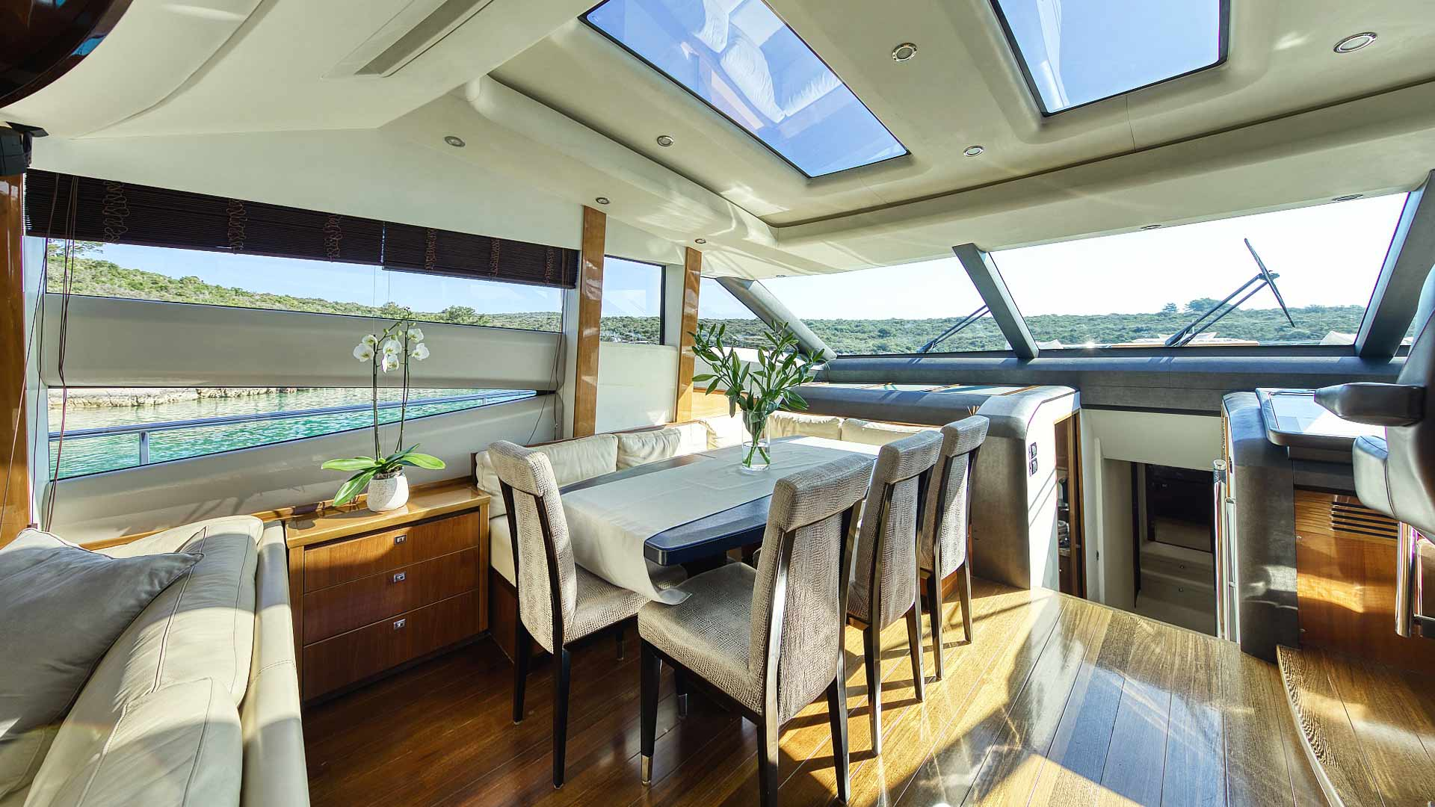

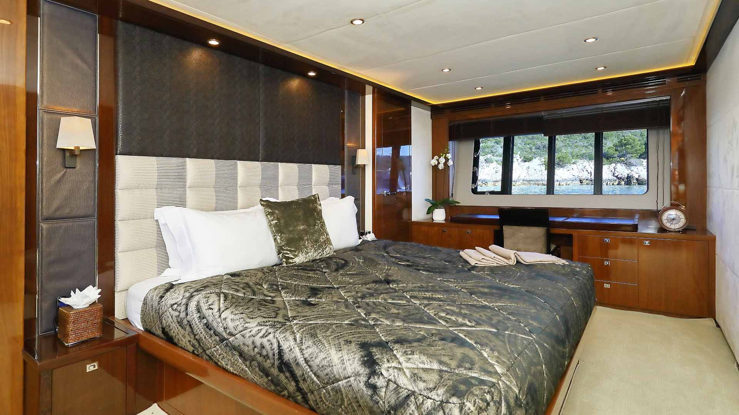

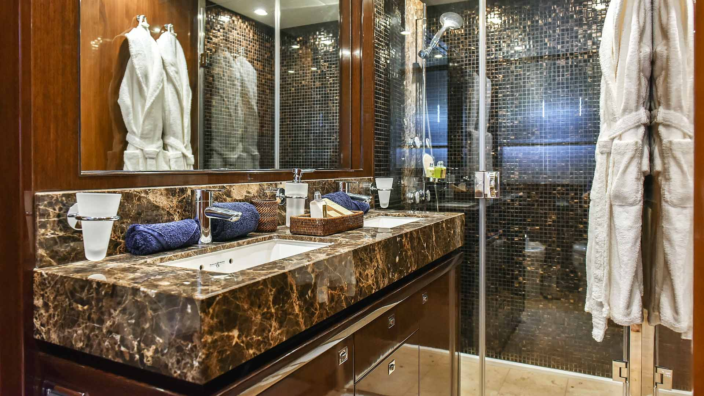

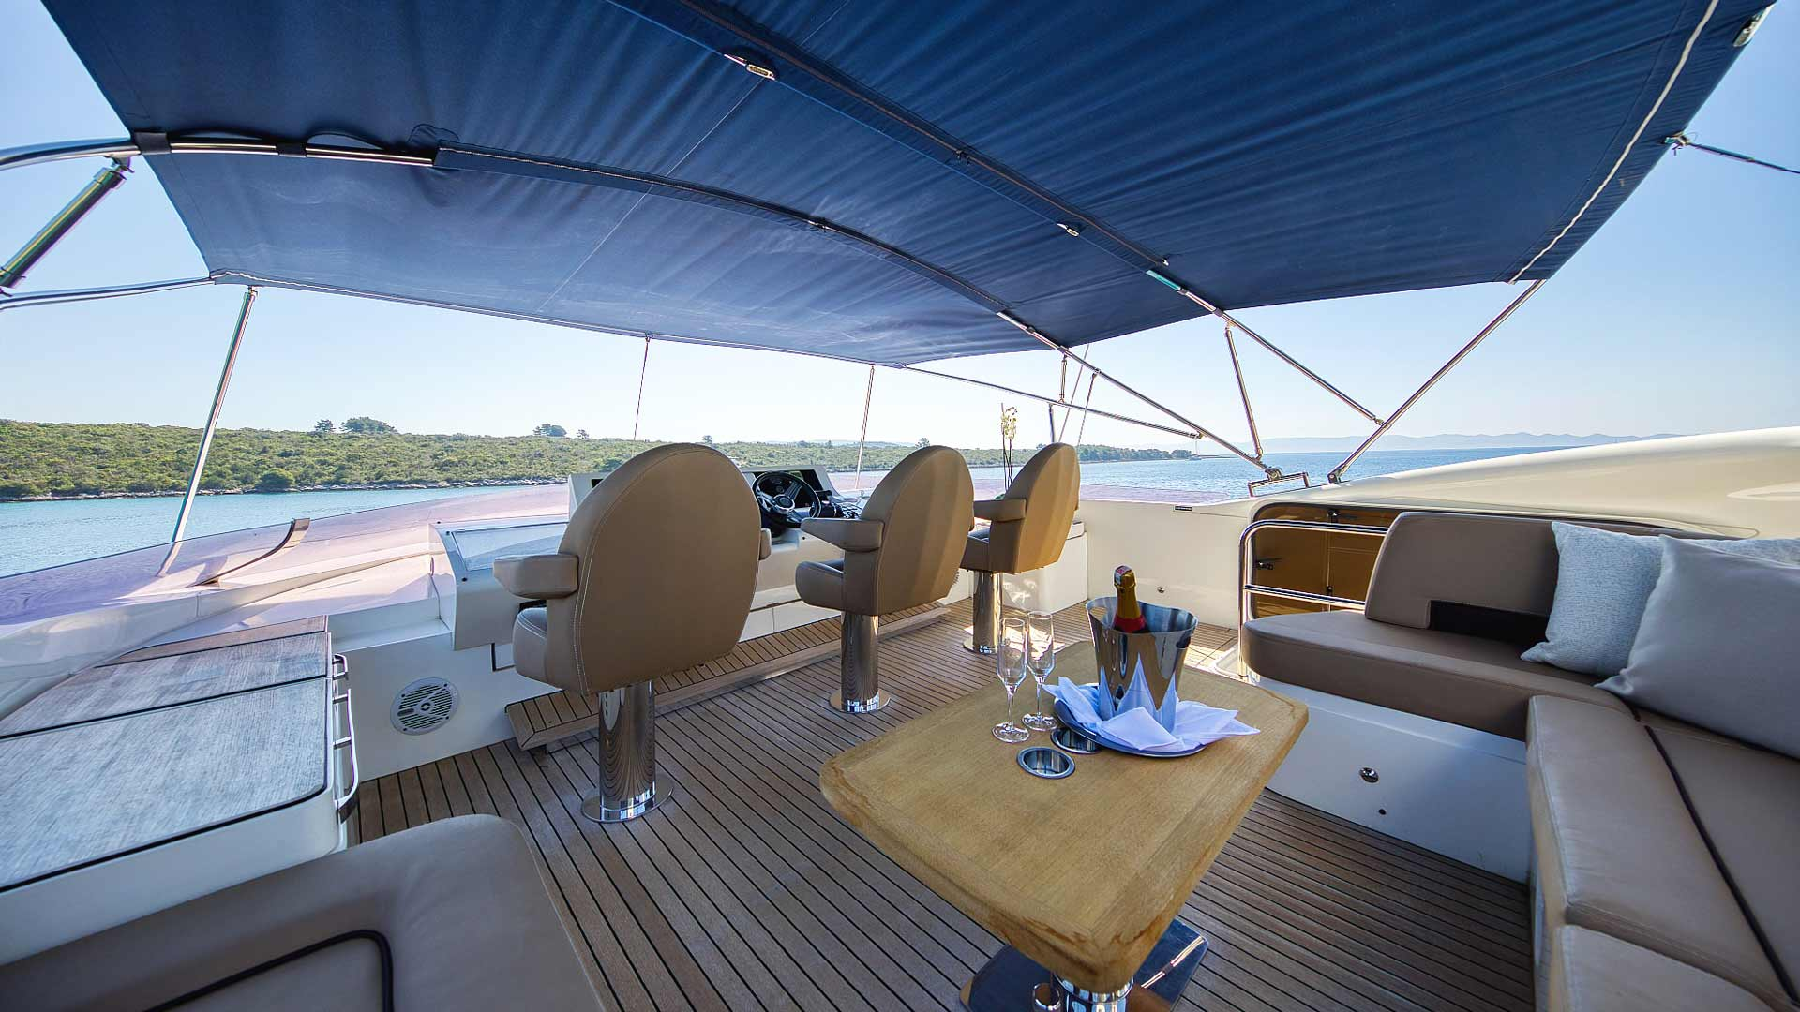

CASSIOPEIA

Cabins- 5 for max occupancy of 111

Size- 34m

Crew- 6

One word I would use to describe this boat is handsome. It was elegant with deep dark wood touches, a worldly elegant interior throughout with comfortable seating, and separate dining space while the rooms are equally as stylish with rich wood accents and spacious en suite bathrooms along with high tech amenities. They make great use of the outdoor space with an expansive sundeck and plenty of seating, a proper bar setup, barbecue, jacuzzi, sun pads and undercover dining area for those ultra sunny days along with a large swim platform which is also great for sunbathing or jumping off into the sea. The boat features a tender and water toys include waterskiis, donuts, kayak, SUPs, Jetski and more.

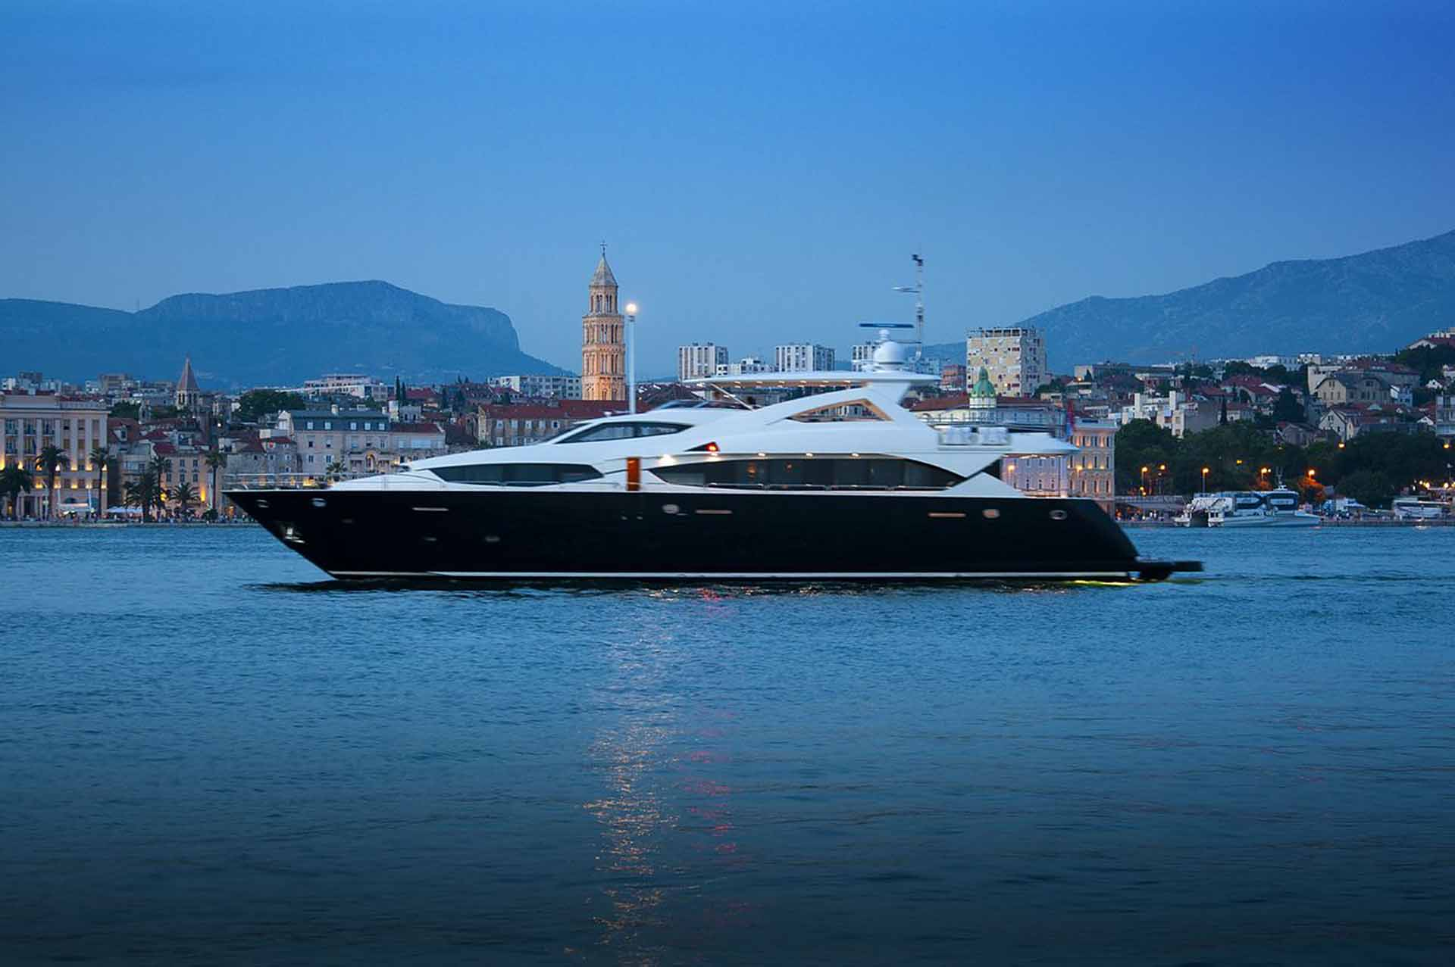

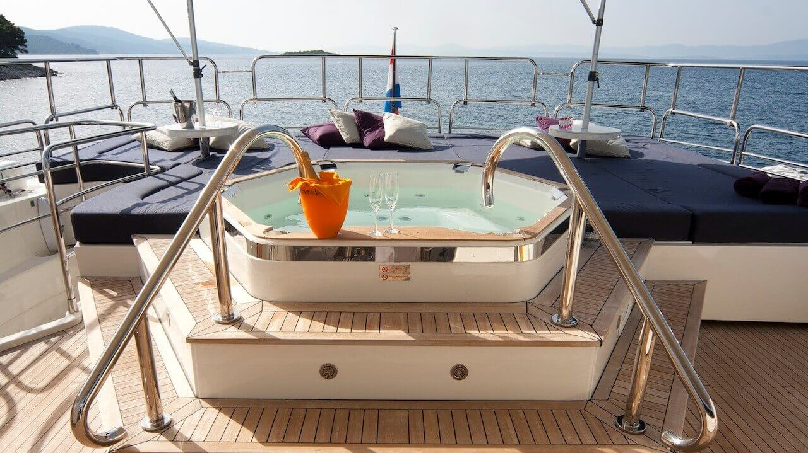

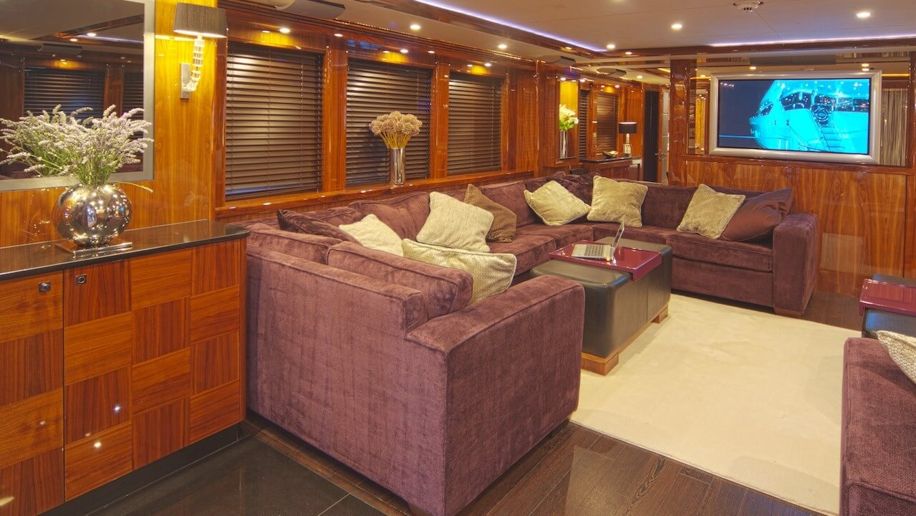

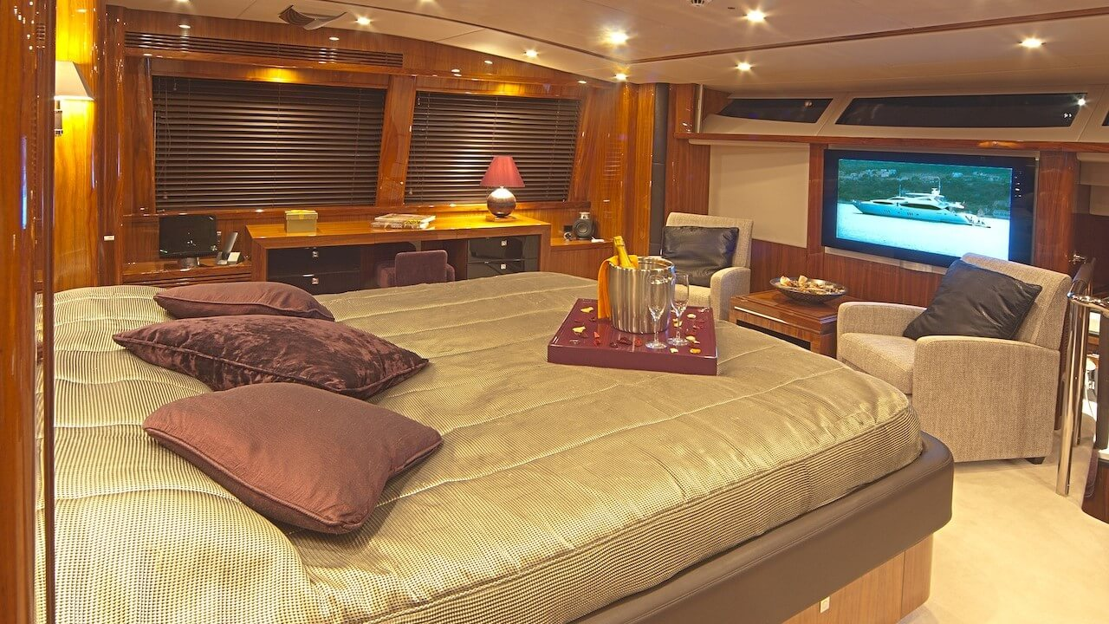

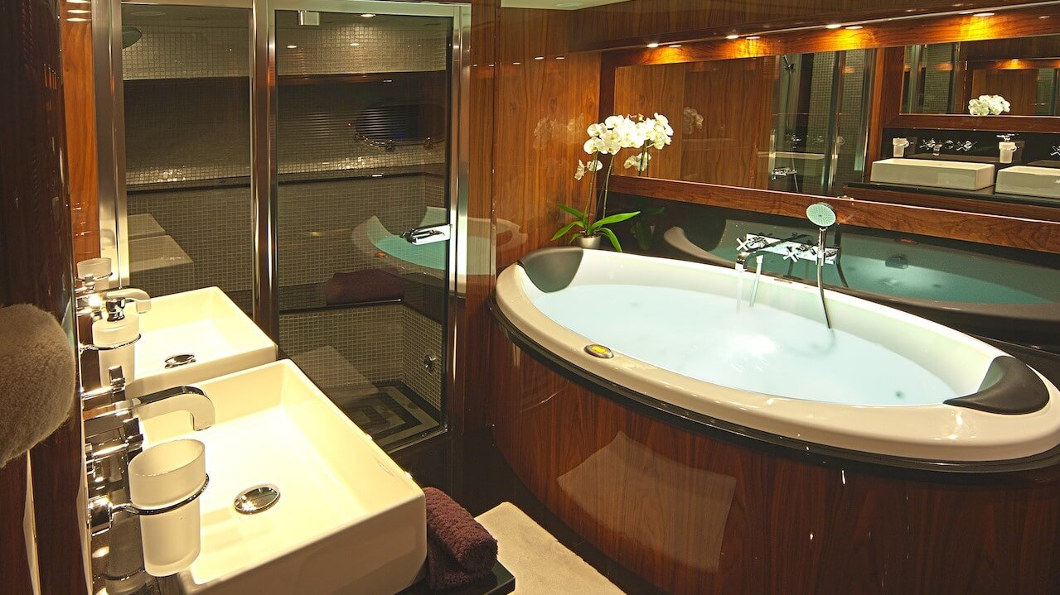

INSIEME

Cabins- 4 for max occupancy of 8

Size- 26 m

Crew- 4
A lovely Princess 85 Fly yacht that was refitted in 2020 so everything looks fresh. It’s smaller in size so more intimate of an experience, great for families or friends who want a calmer, more casual itinerary with less moving around. The salon was spacious and most of the theme across the board is medium brown wood features, sleek design, upgraded sound system and the en-suite bathrooms in each cabin were impressive with unique mosaic-tiled showers. Plenty of space for sunbathing on the deck along with a jacuzzi, and space for al-fresco dining as well as indoor table and one of the cabins has bunk beds which are great for younger kids. Water toys include Jet Ski, Water Skis, Snorkeling equipment and swimming ladder.
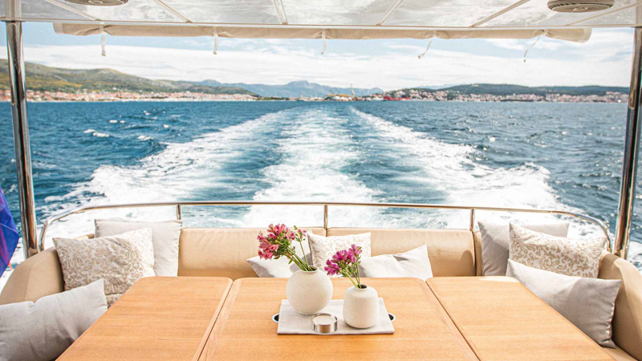
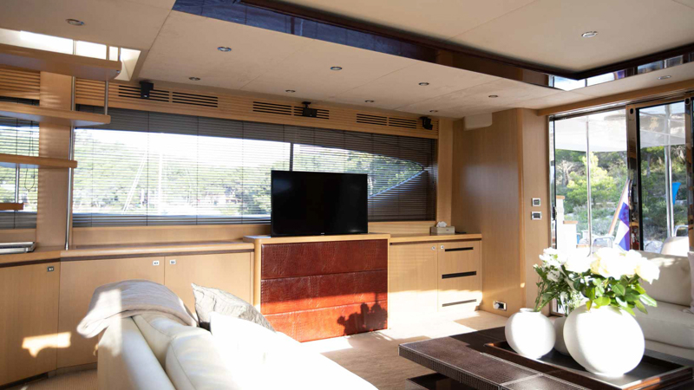

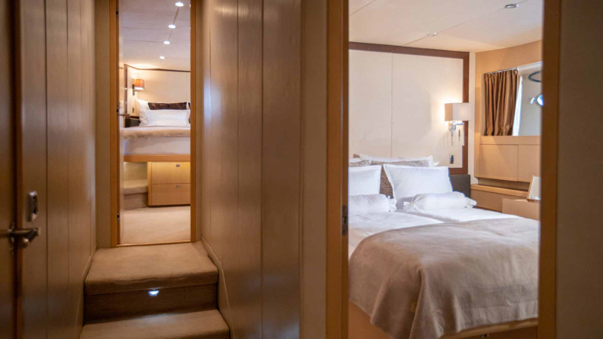

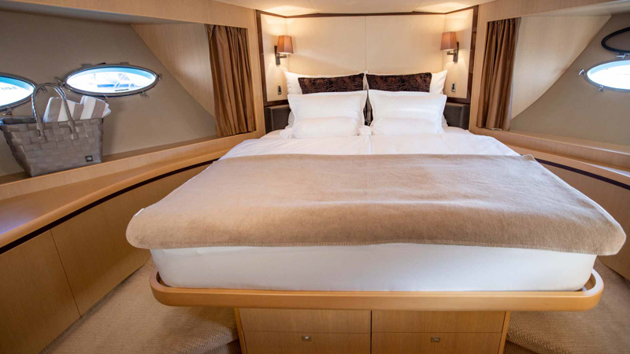

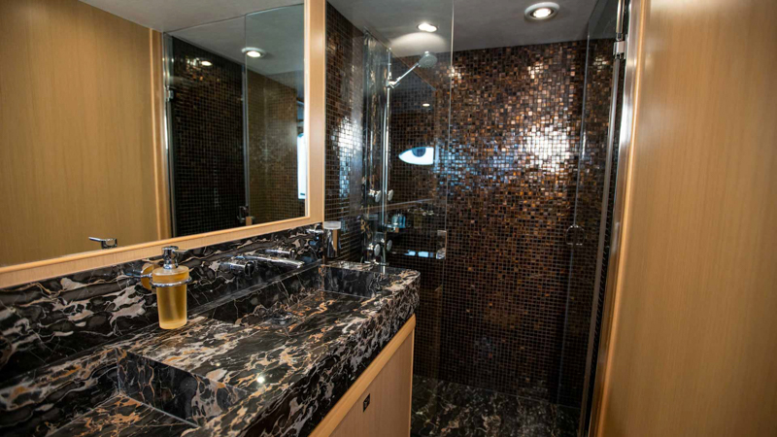

https://via-croatia.com/charter/insieme-motor-yacht/

CLASE AZUL- Sailing yacht

Cabins- 6 for max occupancy of 12

Size- 48m

Crew- 9

Details- I loved this boat from the second I saw it. We were met by the owner who is also the captain (and we could really sense the enthusiasm for their product due to that close tie). It was built locally so it carries with it a huge sense of pride and true to its name, it’s best for a small group of up to 12 and families would absolutely love it.
The rooms are ultra stylish- light and bright with oversized en-suite bathrooms (the master suite has a particularly cool setup with freestanding tub) , all have AC, Hair Dryer, Smart TV, iPad/iPod docking station, WiFi. The crew are young and energetic. They have pretty fabulous touches such as a firepit for the evening, jacuzzi, film screen with projector and one of the most unique underlit translucent dining tables I’ve seen for outdoor dining. They like to play with lighting so at night this vessel looks particularly stunning. Plenty of water toys are available as well including inflatable trampoline, kayaks, water skis, fishing equipment for kids, etc.
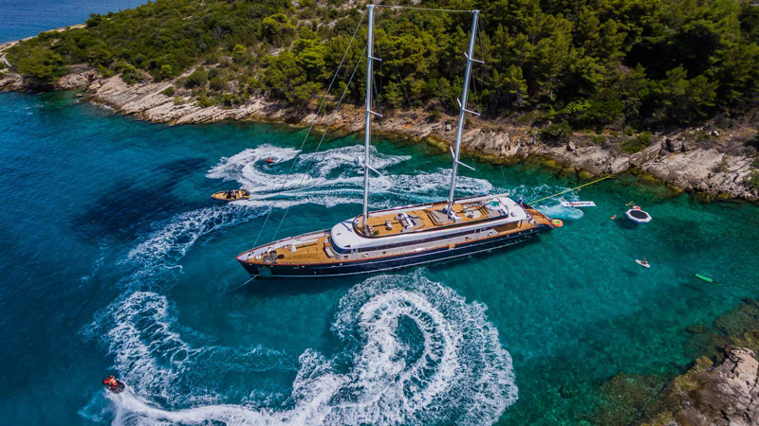
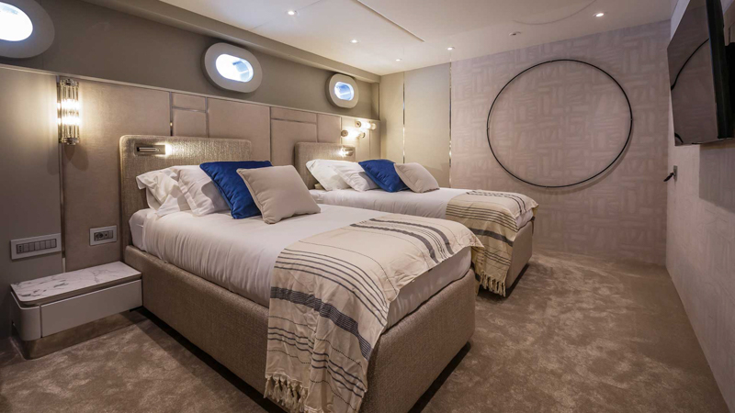

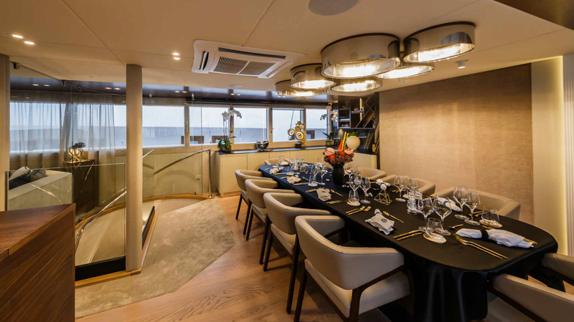
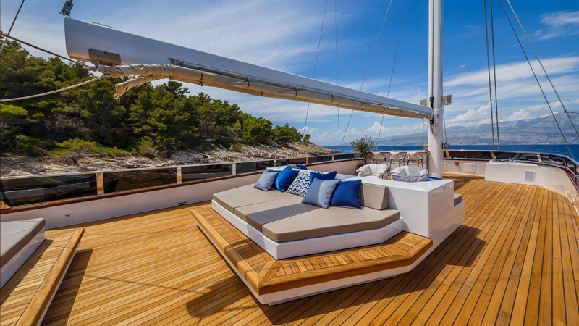

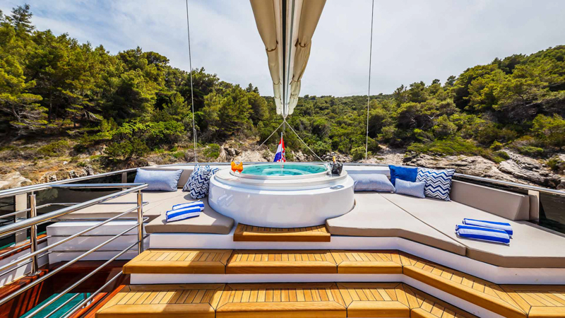

https://via-croatia.com/charter/clase-azul-luxury-sailing-yacht/

